CPR & FIRST AID TRAINING SOUTHEAST TEXAS WWW.CPRCLASSESNOW.COM

Goal: Remain Injury-Free, Knowledgeable In
CPR & AED, & Aware OF Emergency Equipment Locations.

- Are You Prepared For An Emergency?
- A Coworker Collapsed, what is your role?
- Would You Find Yourself In A Panic?

- Every job must have a trained first aid provider AND a back-up on the site, or a designated medical clinic within 4 minutes of the site. Do you know who the first aid provider is on this job? Name and location of on-site first aid provider (or clinic):

- Every job must also have at least one first aid kit, kept in good condition. Do you know where your kits are located. Locations of first aid kits:

- Are you required to post emergency phone numbers on the site, including numbers for a local doctor, hospital, ambulance, and fire department. AND inside operations extensions. Do you know where the numbers are posted on this site? Locations of posted emergency phone numbers (near job telephones or switchboards if any, otherwise in a prominent place):
- What emergency equipment is available for you, and where? Ex: Fire extinguishers, fire blankets, and sand for extinguishing fires, first aid kits, AED, eye wash stations . Types and locations:
Communication devices (Including telephones, intercoms, megaphones, radios, alarms, etc.:
Locations:____________________________________________________________________________________
Stretchers or baskets for moving injured people. Other (For example, special equipment for work in confined spaces, over water, etc.) Types and locations:

- Do you have any questions about how to use our
emergency equipment or what your specific role would be in an emergency? _________________________________________

What steps should you take if someone gets injured?
- SCENE SAFETY
  - Appoint one person to Call 911 and retrieve AED
  - Notify the first aid provider, clinic, or supervisor. Describe the extent of injuries.
  - Give first aid or CPR if necessary and remember proper techniques
  - Keep people out of the area.
  - Calm and reassure the injured person.
  - Do not move them unless life or death until trained help arrives.
  - Stop severe bleeding by applying hand pressure to the wound.
Are there times when you shouldn’t try to help an injured person?
  - Yes. If you will be putting yourself in danger, get help instead of rushing in!
  - Don’t enter a confined space to rescue someone unless you have proper training and equipment.
  - Turn off the power before you approach a victim of electric shock. Do you know where to turn off power?
  - If there’s been a major chemical spill, let a qualified Hazardous Materials (HAZMAT) team respond.
If you’re injured on the job, can you be treated by your own doctor?
- Yes. You can be treated by your own personal physician immediately after a work injury— current recommendation is to provide the company your doctor’s name before you were injured. To be sure your dr is notified, always keep your doctor’s name, address, and phone number on file with the company Do you have any other concerns about job injuries or first aid?
- OSHA REGULATION OSHA requires a written Emergency Action Plan (EAP) if there are more than ten workers on the site. Employees have a right to see a copy. Employers should ensure employees are prepared. Where can you view your EAP and other safety protocols? Point out location:
- COMPANY RULES Aside from OSHA regulations, are there additional company rules or incentives about preventing job injuries, emergency equipment or providing first aid? Discuss company rules:
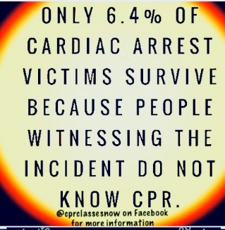
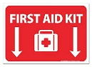

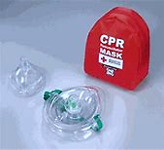

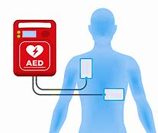

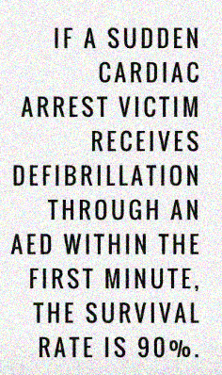
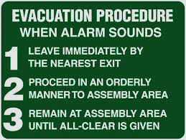

‘

CPR & FIRST AID TRAINING SOUTHEAST TEXAS
Electric Power Generation, Transmission and Distribution:
Fall Protection Requirements
WORKING SAFELY WITH ELECTRICITY
Working around live electricity is a serious hazard. Engineers, linemen, electricians,
and others who work with electricity directly, and workers who work with electricity
indirectly may be exposed to serious electrical hazards.

Generators
Generators are commonly used as a replacement source of electricity when electrical power is lost. Most generators are gasoline or diesel powered with internal combustion engines which turn an alternator to produce electricity. One of the hazards from gasoline or diesel powered engines is carbon monoxide (CO). Carbon monoxide is a colorless, odorless gas produced during the operation of gasoline powered generators. When inhaled, the gas reduces your ability to transport oxygen.
Symptoms of carbon monoxide poisoning include headache, nausea and fatigue that can lead to unconsciousness and ultimately prove fatal. The following information is a list of best practices to identify hazards when operating around power lines and electrical equipment.
- DO NOT operate a generator indoors. Generators should be placed outdoors in a location where the exhaust gases cannot enter a home or building. Good ventilation is key to operating a generator safely.
- Be sure the main circuit breaker is OFF and locked out prior to starting any generator. This will prevent inadvertent energization of power lines from back feed electrical energy from generators and help protect utility line workers from electrocution.
- Turn off generators and let them cool prior to refueling.

Power Lines
Overhead and buried power lines are especially hazardous because they carry dangerously high voltage. Fatal electrocution is the main risk, but burns and falls are also hazards.
- Look for overhead power lines and buried power line indicators.
- Stay at least 10 feet away from overhead power lines and assume they are energized.
- De-energize and ground lines when working near them.
- Use non-conductive wood or fiberglass ladders when working near power lines.

Extension Cords
Worn cords can expose the wires within, or loosen the connections on the plug end. Extension cords that are not 3-wire type, not designed for hard-usage, or that have been modified are not as durable. These conditions can increase the risk of electric shock.
- Use equipment that is approved by a nationally recognized testing laboratory.
- Do not modify cords or use them incorrectly.
- Use factory-assembled cord sets and extension cords that are 3-wire type.
- Use cords, connection devices, and fittings equipped with strain relief.
- Remove cords from receptacles by pulling on the plugs, not the cords.

Equipment
Due to the dynamic, rugged nature of construction work, normal use of electrical equipment causes wear and tear that results in insulation breaks, short-circuits, and exposed wires. If there is no ground-fault protection, it can cause a ground-fault that sends current through a worker’s body.
Use ground-fault circuit interrupters (GFCIs) on all 120-volt, single-phase, 15- and 20-ampere receptacles that are not on an existing building’s permanent wiring, or have an assured equipment grounding conductor program (AEGCP).
- Use double-insulated tools and equipment, distinctively marked.
- Visually inspect all electrical equipment before use. Remove from service any equipment with frayed cords, missing ground prongs, cracked tool casings, etc.

Electrical Incidents
If the power supply to the electrical equipment is not grounded or the path has been broken, fault current may travel through a worker’s body, causing electrical burns or death. Visually inspect electrical equipment before use. Take any defective equipment out of service.
- Ground all power supply systems, electrical circuits, and electrical equipment.
- Frequently inspect electrical systems to ensure that the path to ground is continuous.
- Do not remove ground prongs from cord- and plug-connected equipment or extension cords.
- Use double-insulated tools and ground all exposed metal parts of equipment.
- Avoid standing in wet areas when using portable electrical power tools.

Workers’ Rights
Workers have the right to:
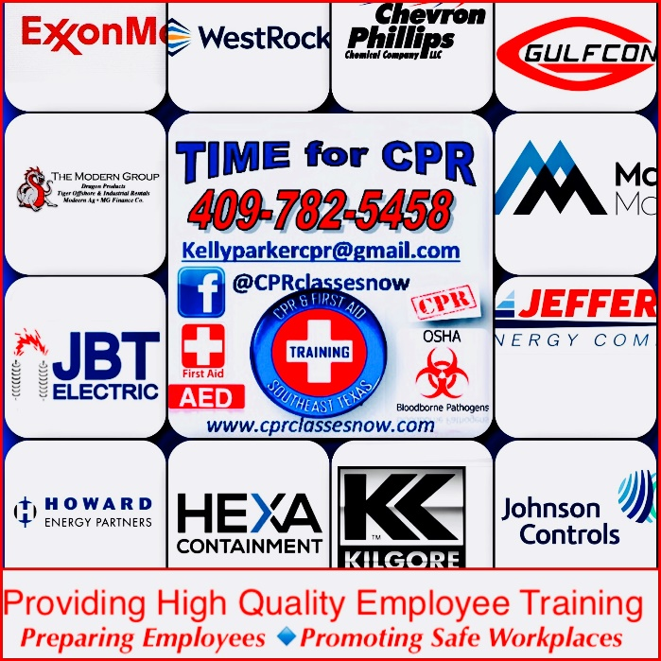
- Working conditions that do not pose a risk of serious harm.
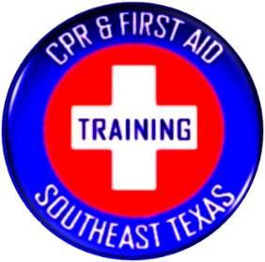
- Receive information and training (in a language and vocabulary the worker understands) about workplace hazards, methods to prevent them, and the OSHA standards that apply to their workplace.
- Review records of work-related injuries and illnesses.
- File a complaint asking OSHA to inspect their workplace if they believe there is a serious hazard or that their employer is not following OSHA’s rules. OSHA will keep all identities confidential.
- Exercise their rights under the law without retaliation, including reporting an injury or raising health and safety concerns with their employer or OSHA. If a worker has been retaliated against for using their rights, they must file a complaint with OSHA as soon as possible, but no later than 30 days.

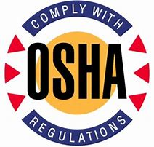
How to Contact OSHA
Under the Occupational Safety and Health Act of 1970, employers are responsible for providing safe and healthful workplaces for their employees. OSHA’s role is to ensure these conditions for America’s working men and women by setting and enforcing standards, and providing training, education and assistance. For more information, visit www. osha.gov or call OSHA at 1-800-321-OSHA (6742), TTY 1-877-889-562
www.cprclassesnow.com
This fact sheet discusses specific fall protection requirements in OSHA’s revised
§1910.269 and §1926, Subpart V. Employers doing work covered by these revised Electric Power Generation, Transmission and Distribution standards must assess the worksite where fall protection is needed to protect workers.

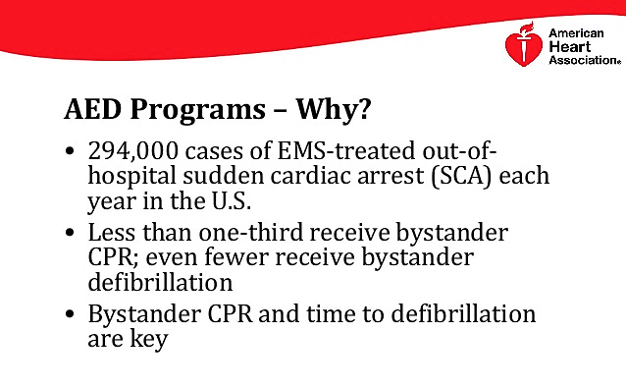
4 Most common construction and industrial deaths:
1. Falls: The leading cause of construction workplace deaths in 2016 was from falls and each year more than 100,000 injuries or deaths are attributable to work-related falls. In construction proper fall protection is not always equipped, used correctly or replaced as needed. Provide a guard rail and toe-board around every elevated open sided platform, floor, and runway, as well as around dangerous machines and equipment. Include safety harness and line, safety nets, stair railings and hand rail if required on the job site.
2. Electrocution: The second leading cause of construction workplace deaths in 2016 was electrocution. In fact, electrical hazards cause more than 300 deaths and 4,000 injuries in the workplace each year. Electricity is a serious workplace hazard, and sadly many of these injuries and fatalities could be easily avoided. Remember the importance of PPE even if it slows work down.
3. Struck-by-
Content belongs to- CPR & First Training Southeast Texas © 2017-2018

Object: The third leading cause was struck-by-object which includes objects that are falling (suspended load coming loose), flying (thrown tools or debris), swinging (load swaying) or rolling (vehicle or heavy equipment in motion). Workers are often caught off guard and do not have enough time to react. Wear safety glasses, goggles or a face shield when using power tools and ensure protective guards are in good condition. Secure tools and materials. Always wear a hard hat while on the construction site. Never position yourself under a suspended load, verify the heavy equipment operator sees you.
4. Caught-in-Between: The fourth leading cause of construction workplace deaths in 2016.. These are accidents where a worker’s body part is caught, crushed or squeezed between two or more objects and happen from collapsing materials; body parts pulled into unguarded machinery and equipment rollovers. Know where the pinch, sheer, wrap and crush points are located, and the pull-in areas. Shut down equipment before doing repairs or inspections and lock wheels.
*Wear close-fitting clothing, avoid jewelry, pull back long hair to prevent being caught in moving machinery*
What can drive workplace safety: *Get it done: Unsafe practices that are justified by tight timelines. Discuss don’t rush. *Undiscussed incompetence: Unsafe practices that stem from skill deficits that workers think can't be discussed. If you don’t know you have to learn. Don’t pass down ways to cut corners.
*Just this once:. Unsafe practices that are justified because they are exceptions to the rule. Unsafe practices that bypass precautions management or workers are never justifiable, not even once. *SAFETY CHECK* : There is no one more important than you. Before helping: first take care of yourself before anyone else. Rushing into a situation without checking for safety may result in personal injury. Some of the things to check for include: Fumes, smoke, fires, falling objects, broken glass on the floor where you’ll be kneeling, Electrical wires/sources, Oncoming traffic if on the road.
*When presented with danger: choices. 1. Get help and stay away from the danger. 2. Move the victim away from the danger. 3. Eliminate the danger safely (example: open windows to expel fumes etc). Remember, if you get hurt you are not going to be able to help anyone else.

SERVICES AVAILABLE FOR YOUR COMPANY:
TRAINING AND CERTIFICATIONS:

www.cprclassesnow.com

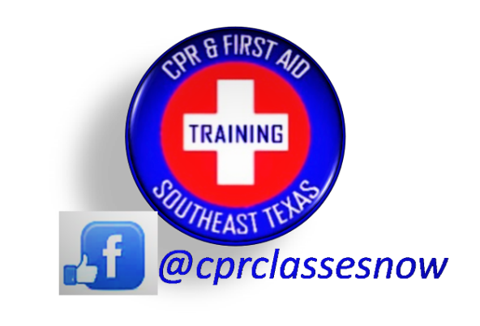
TRAINING AND CERTIFICATIONS:

- CPR CERTIFICATION
- AED CERTIFICATION
- BASIC FIRST AID CERTIFICATION
- BLOOD BORNE PATHOGEN CERTIFICATION

IN-SERVICES & TRAINING:
- AED IMPLEMENTATION- GUIDE TO START & UNDERSTAND A WORKPLACE SAFETY PROGRAM
- FIRST AID KIT AND EYE WASH STATION MAINTENANCE PROTOCOL
- OTHER EMERGENCY SUPPLIES MAINTENANCE PROTOCOL
- ACCIDENT PREVENTION TRAINING
- COMMON WORKPLACE HAZARDS DESIGNED FOR YOUR WORKPLACE
- EMPLOYEE SAFETY WORKSHEETS

ADDITIONAL RESOURCES FOR YOUR FACILITY:
- First Aid Kits
- Eye Wash Stations
- Employee Awards
- Workplace Safety Reminder Posters
- Pamphlets
- Safety Signs
- Safety Equipment Placement As Recommended Per Osha

AED Certification
Basic First Aid Certification
WWW.CPRCLASSESNOW.COM
Blood Borne Pathogen Certificati
In-services and workshops:
AED implementation Guide
Workplace Safety Start Program
First Aid Kit and Eye Wash Station
Emergency Supplies Maintenance Prot
In-services:
Accident Prevention
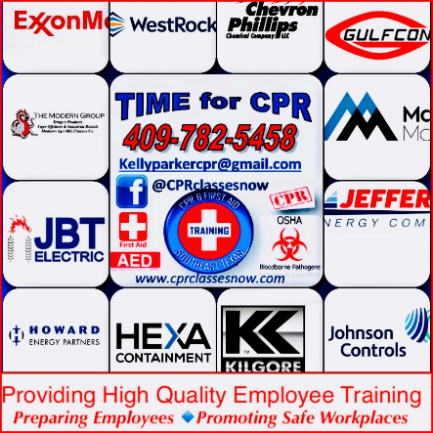
Common Workplace Hazards Employee Safety Worksheets Additional Topics Available upon requ
409-782-5458
Resources for your facility:
First Aid Kits Eye Wash Stations
Employee Awards
Workplace Safety Reminder Posters
Pamphlets
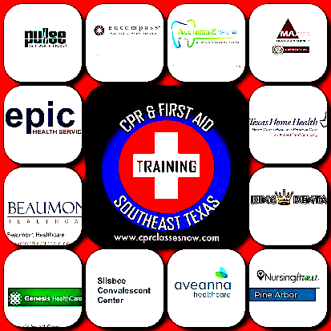
Safety Signs
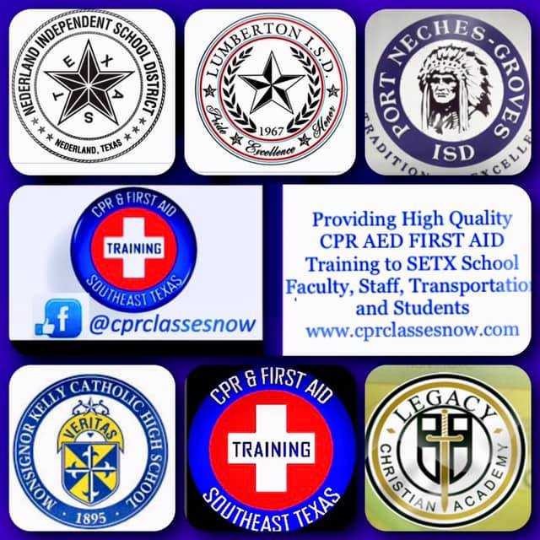
www.cprclassesnow.com

